

OASIS – ADDNITSDNR Rollover Help document
Workaround To submit Designation Extension with OATI sytem update
By SPP Staff/Transmission Services
Published on 10/23/2026
Version Orig.

Revision History
Date or version number | Author | Change Description | Comments
Original 10/23/2026 | SPP Staff | NEW

Contents
Revision History i
Background 1
User Requirements 1
Procedure 2
New ADDNITSDNR Fields added during the update 2
Errors when submitting aRollover an ADDNITSDNR with separate ADD/MODIFYNITSRESOURCE TSR: 3
Workaround resolution for submitting ADDNITSDNR with separate ADD/MODIFYNITSRESOURCE TSR 5
Errors when Rolling over an ADDNITSDNR where the resource is created within the ADDNITSDNR 6
Workaound resolution for submitting ADDNITSDNR where the resource is created within the ADDNITSDNR 12
Terms and Acronyms 14

Background
Recent Updates to OATI OASIS have added new fields to the ADDNITSDNR regarding Rollover Waivers, Renewal Times and Related Resources. Due to the new configuration in the software, New and Existing ADDNITSDNRs are not auto-populating as anticipated with this information. SPP is working with OATI to resolve this issue. Until a resolution is implemented, the workaround described herein should help circumnavigate the issues encountered when rolling over ADDNITSDNRs.
Herein is a description of the issues encountered when attempting to submit an ADDNITSDNR DESIGNATION_EXTENSION when trying to implement Rollover rights, and the workaround process.

User Requirements
Access to OATI HUB™
Permission in OATI OASIS to submit TSRs.

Procedure
The following errors have been identified and verified Workaround Processes are presented until OATI OASIS is able to correct the issues experienced within the latest software update hindering submission of ADNITSDNR as a DESIGNATION_EXTENSION.

New ADDNITSDNR Fields added during the update
New and Existing ADDNITSDNR have additional field entries which were intended to be auto-populated both during retroactively or during new submissions of ADDNITSDNRs into OASIS. This field is not populated appropriately by OASIS and remains blank.
- The updates can be seen as follows:
  - Rollover Waived
  - Renewal Due Time
  - Related Resource

- From our assessment these fields should be auto-populated. Due to an error in the programming, this is not the case and the cause of the errors encountered when trying to submit rollover submissions for ADDNITSDNR.
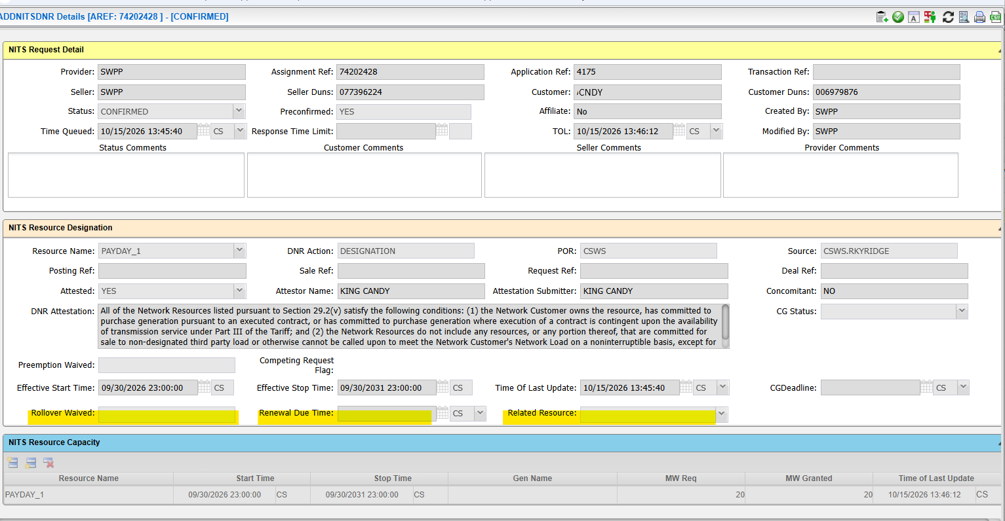

Errors when submitting a Rollover for ADDNITSDNR with separate ADD/MODIFYNITSRESOURCE TSR:
- Errors with the Standard procedure for rollover of an ADDNITSDNR.
  - DNR Action set to DESIGNATION_EXTENSION
  - Related Resource left blank
  - Start and Stop Time only modifications for rollover
- Errors Encountered when trying to submit an ADDNITSDNR as a DESIGNATION_EXTENSION
  - RELATED RESOURCE is required when submitting DNR Action DESIGNATION_EXTENSION.
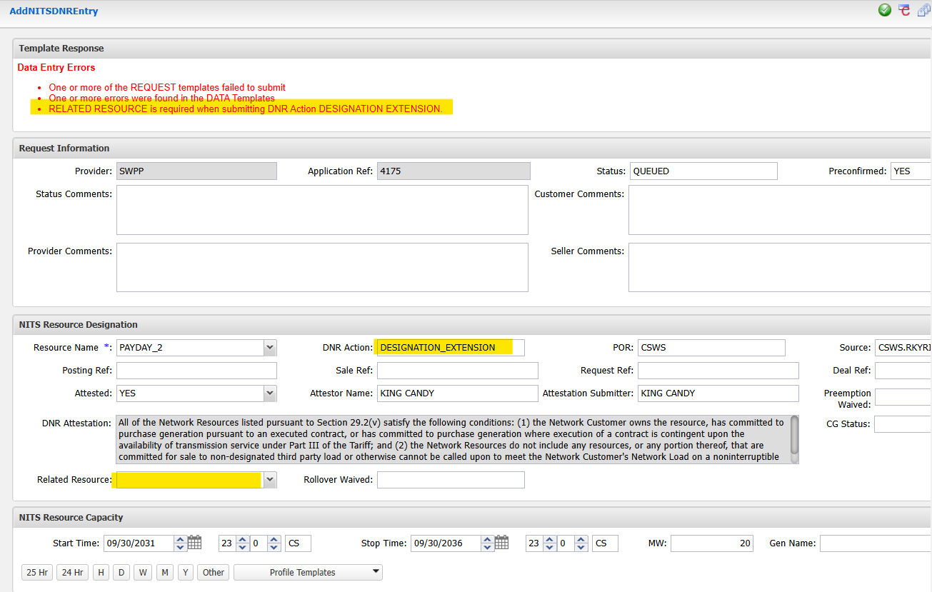
- Explanation of Error:
  - OASIS is looking for the submitted to supply data in the Related Resource field in this example PAYDAY_2 should provide resolution.
  - Due to the lack of population in the ADDNITSDNR for the fields Rollover Waived, Renewal Due Time and Related Resource. Presumably, adding the Related Resource name will provide resolution.
- Errors with the Updated procedure for rollover of an ADDNITSDNR.
  - DNR Action set to DESIGNATION_EXTENSION
  - Related Resource populated to match resource name
  - Start and Stop Time only modifications for rollover

- Errors Encountered when trying to submit an ADDNITSDNR as a DESIGNATION_EXTENSION with a Related Resource selected
  - There is no rollover data on Related Resource PAYDAY_2.
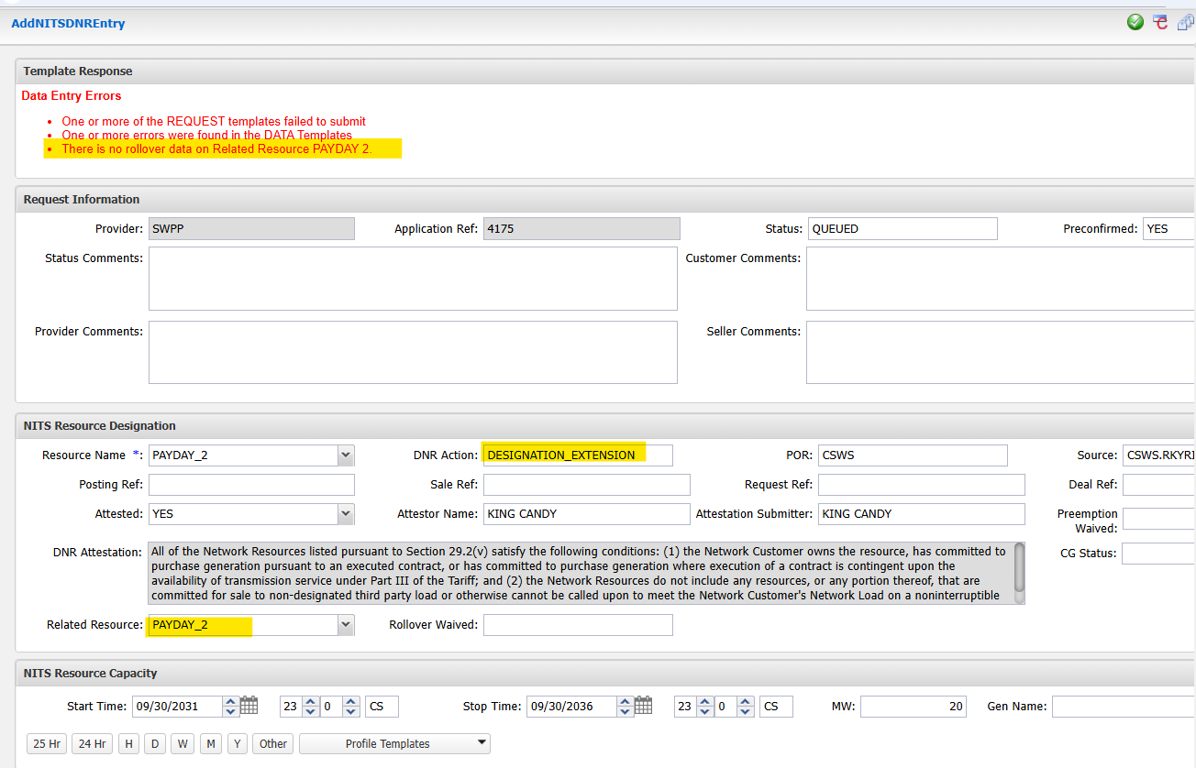
- Explanation of Error:
  - Due to the lack of population in the ADDNITSDNR for the fields Rollover Waived, Renewal Due Time and Related Resource. The system is not seeing the rollover data and failing to submit the ADDNITSDNR

Workaround resolution for submitting ADDNITSDNR with separate ADD/MODIFYNITSRESOURCE TSR
- Populate the ADDNITSDNR as Follows:
  - DNR Action set to DESIGNATION
  - Related Resource field Blank
  - Start and Stop Time only modifications for rollover

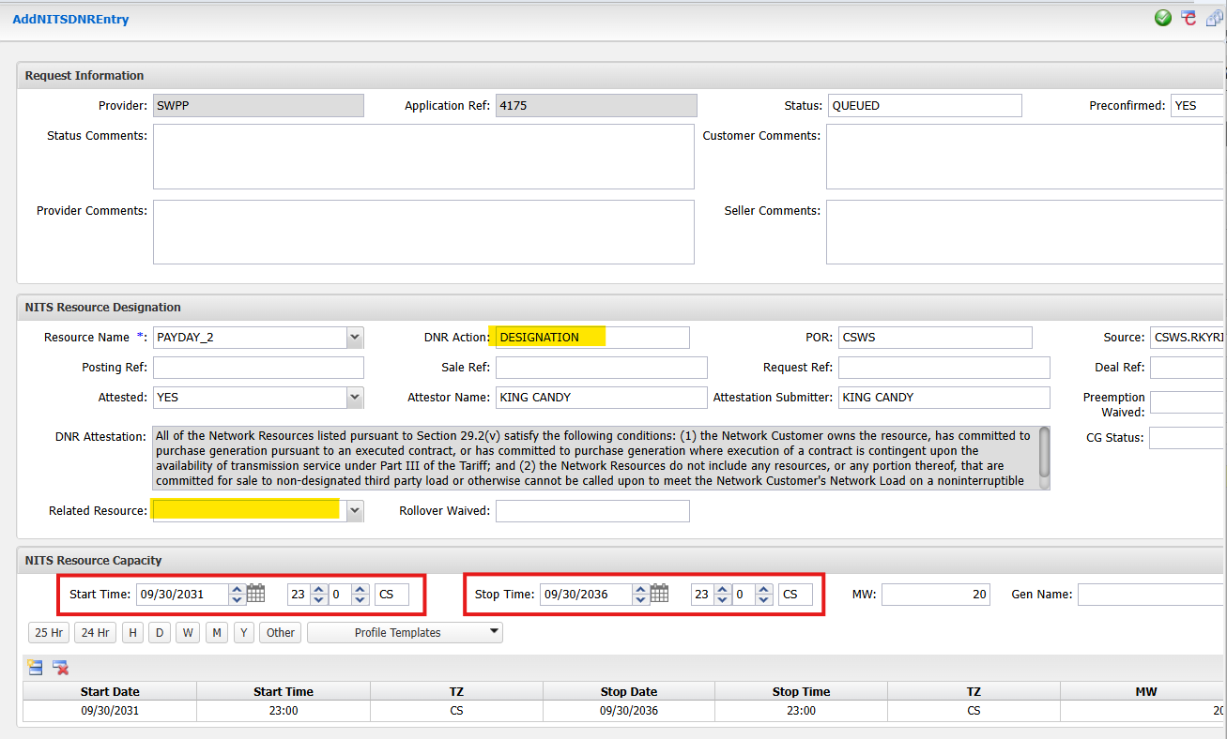
This should allow submission of the ADDNITSDNR rollover request.
.

Errors when Rolling over an ADDNITSDNR where the resource is created within the ADDNITSDNR
When attempting to roll over an ADDNITSDNR where the resource is created within the ADDNITSDNR, similar errors occur to as described above.
Below describes the errors that may be encountered when attempting to submit an ADDNITSDNR as a DESIGNATION_EXTENSION where the Resource is defined within the ADDNITSDNR.
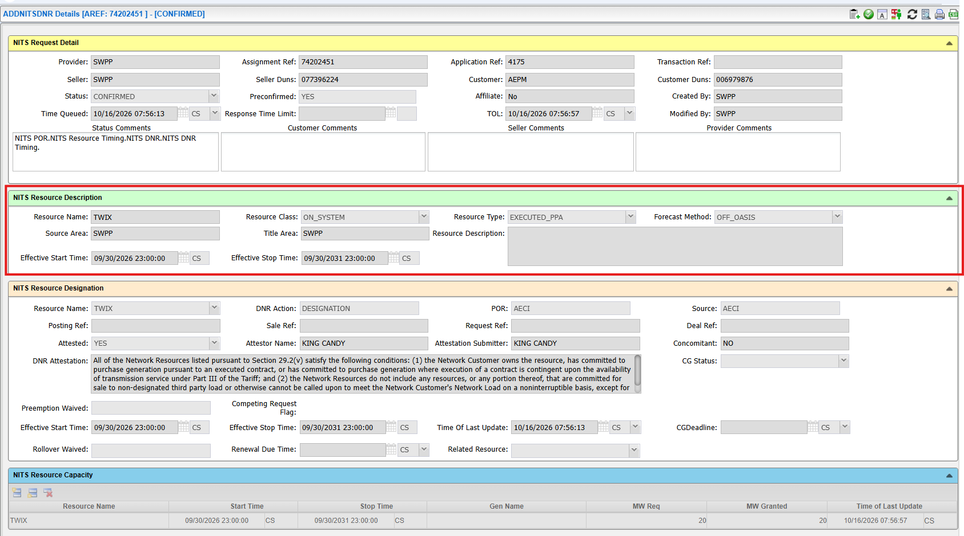

- Errors encountered when using the Standard Procedure for rollover presenting the errors highlighted below.
  - DNR Action set to DESIGNATION_EXTENSION
  - Related Resource left blank
  - Start and Stop Time only modifications for rollover
- Errors Encountered when trying to submit an ADDNITSDNR as a DESIGNATION_EXTENSION
  - RESOURCE NAME (TWIX) is already defined
  - RELATED RESOURCE is required when submitting DNR Action DESIGNATION_EXTENSION.
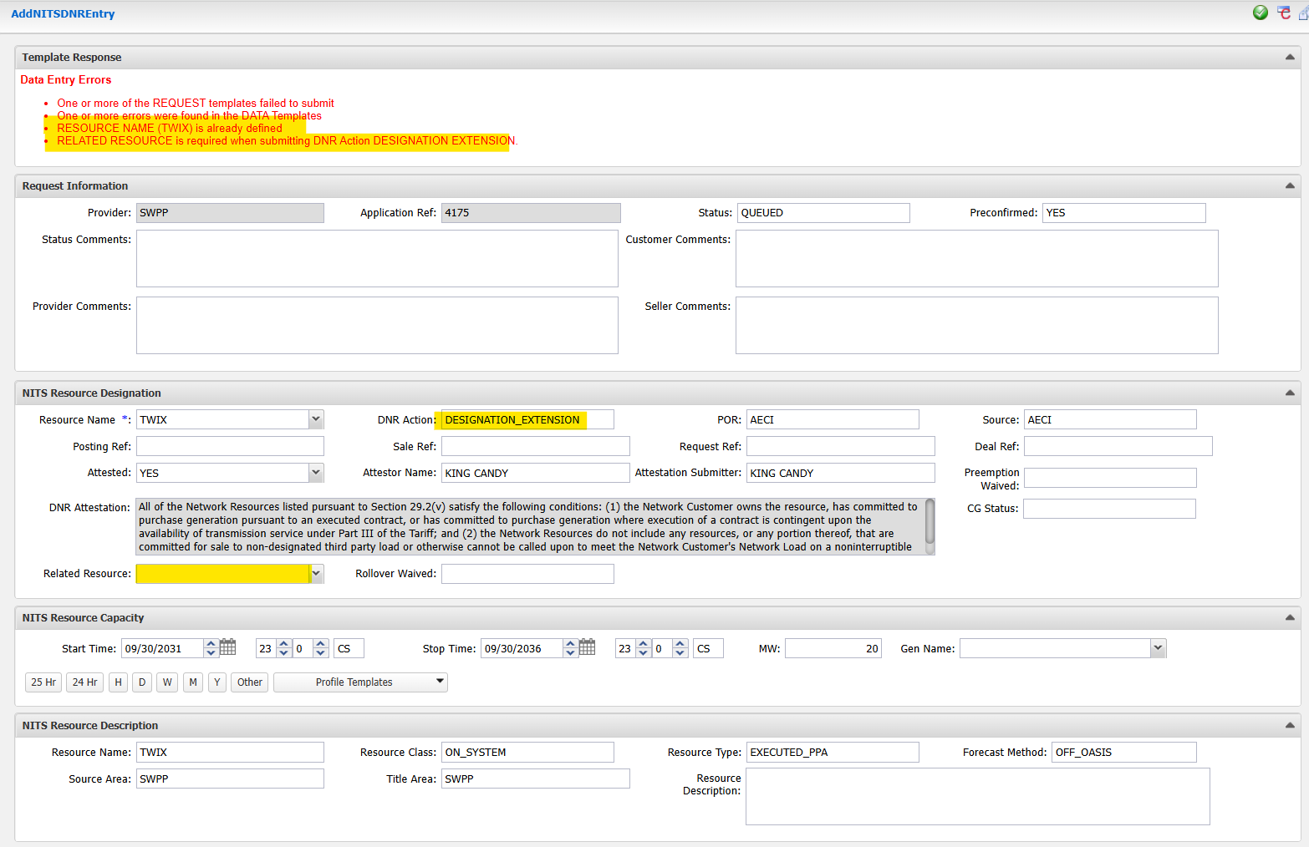

- Explanation of Error:
  - Although the DNR Action DESIGNATION_EXTENSION is selected the system believes a new Resource of an existing name is being created
    - System Logic would expect that the NITS Resource Description would not be necessary and logic incorrectly expects it to be removed.
    - The system has disabled the ability to deselect NITS Resource Description

  - As the submission is a DESIGNATION_EXTENSION the system expects the Related Resource field to be populate in this example (TWIX)
- Errors encountered when using the Updated Procedure for rollover presenting the errors highlighted below.
  - DNR Action set to DESIGNATION_EXTENSION
  - Related Resource populated to match resource name
  - Start and Stop Time only modifications for rollover

- Errors Encountered when trying to submit an ADDNITSDNR as a DESIGNATION_EXTENSION
  - RESOURCE NAME (TWIX) is already defined
  - There is no rollover data on Related Resource TWIX.
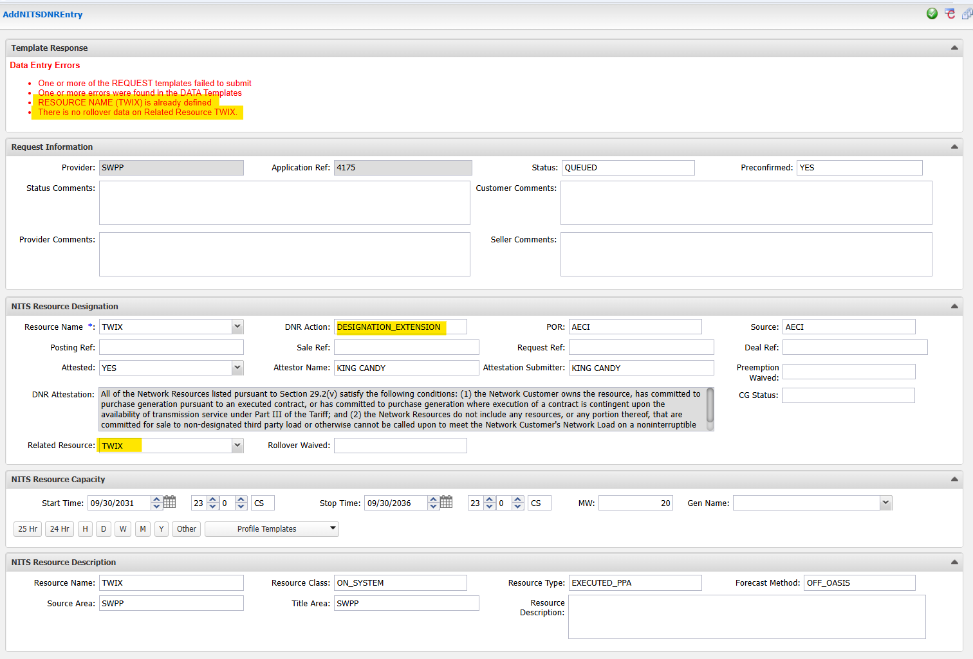
- Explanation of Error:
  - Although the DNR Action DESIGNATION_EXTENSION is selected the system believes a new Resource of an existing name is being created
    - System Logic would expect that the NITS Resource Description would not be necessary, and logic incorrectly expects it to be removed.
    - The system has disabled the ability to deselect NITS Resource Description
  - Due to the lack of population in the ADDNITSDNR for the fields Rollover Waived, Renewal Due Time and Related Resource. The system is not seeing the rollover data and failing to submit the ADDNITSDNR.
- Trying the same workaround for when a separate ADD/MODIFYNITSRESOURCE TSR exists and populating the rollover ADDNITSDNR similarly the following is encountered:
- The following error may be encountered when using the Workaround Procedure for rollover presenting the errors highlighted below.
  - DNR Action set to DESIGNATION
  - Related Resource left blank
  - Start and Stop Time only modifications for rollover

- Errors Encountered when trying to submit an ADDNITSDNR as a DESIGNATION_EXTENSION
  - RESOURCE NAME (TWIX) is already defined

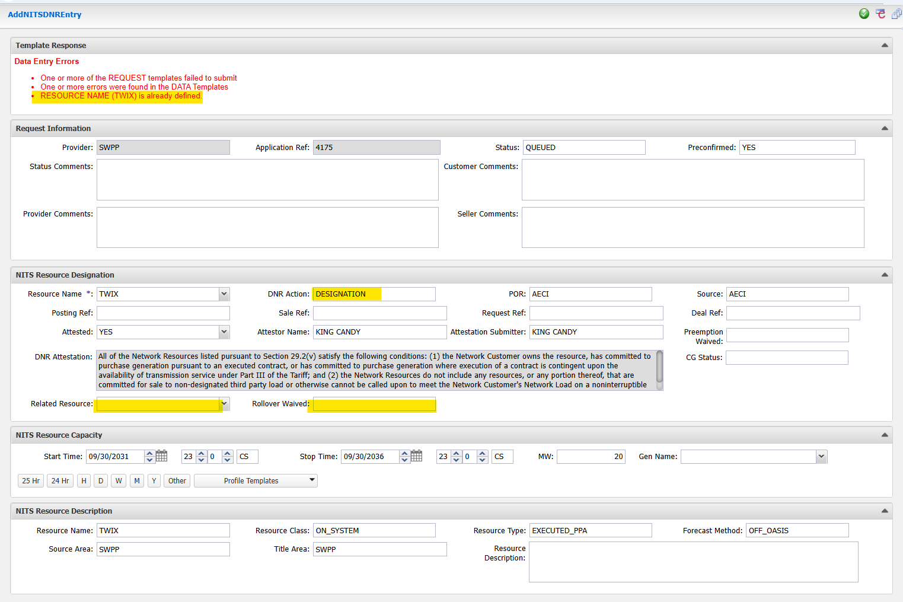

- Explanation of Error:
  - Although the DNR Action DESIGNATION_EXTENSION is selected the system believes a new Resource of an existing name is being created
    - System Logic would expect that the NITS Resource Description would not be necessary, and logic incorrectly expects it to be removed.
    - The system has disabled the ability to deselect NITS Resource Description

Workaound resolution for submitting ADDNITSDNR where the resource is created within the ADDNITSDNR
- Populate the ADDNITSResource as Follows:
  - Resource Name: PAYDAY_1 (same as resource listed in DNR wishing to rollover)
  - Forecast Method: ON_OASIS
  - Start and Stop Time only modifications to include the rollover period
  - Other appropriate fields as necessary for resource definition
  - †Forecast: populated to match resource amount and start/stop time of ADDNITSRESOURCE
†Note: Some ADDNITSResource TSRs are presenting with the following error if you do not include the NITS Resource Forecast: -Invalid use of DATA Template delete(below). Be sure to right click on a blank area in the submission box and select NITS Resource Forecast to include this data if you try to submit without a NITS Resource Forecast and experience this submission error.
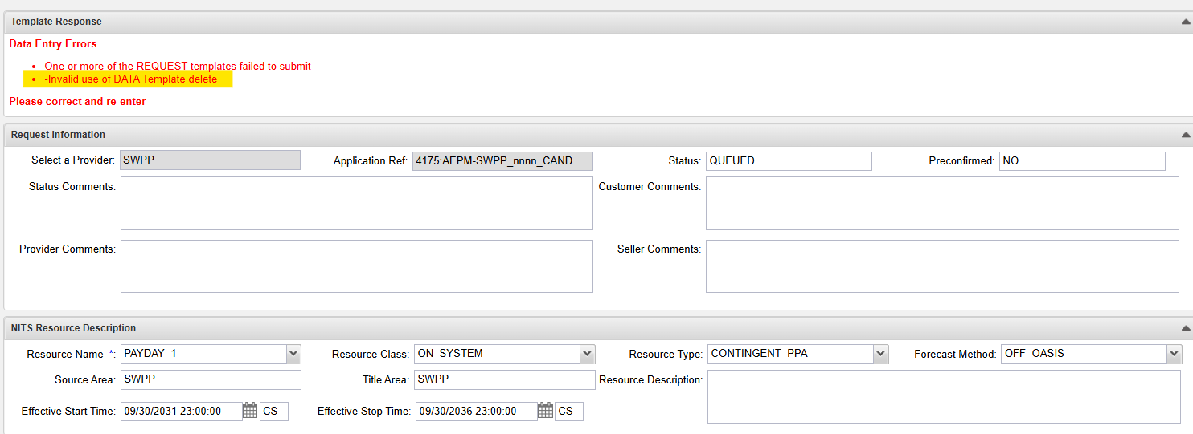
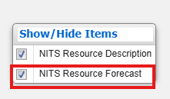

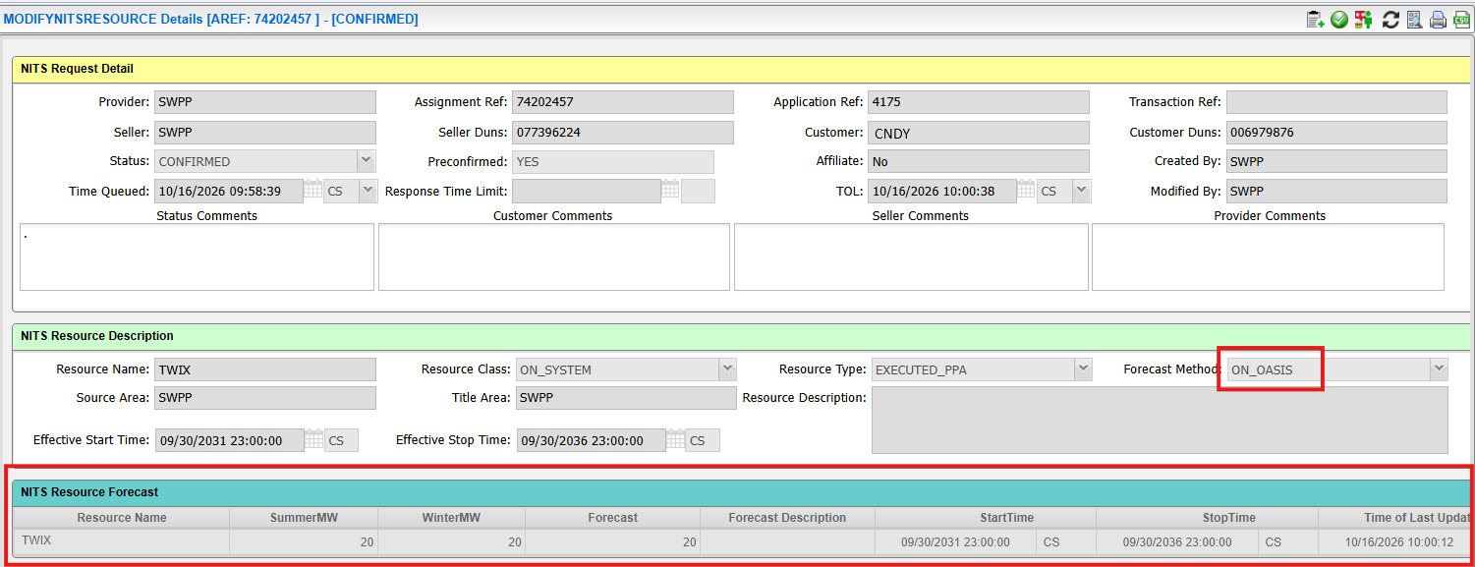
This should allow submission of the ADDDNITSRESOURCE extension to submit

- Populate a new ADDNITSDNR as Follows:
  - DNR Action set to DESIGNATION
  - Related Resource field Blank
  - Start and Stop Time only modifications to match the rollover time frame.

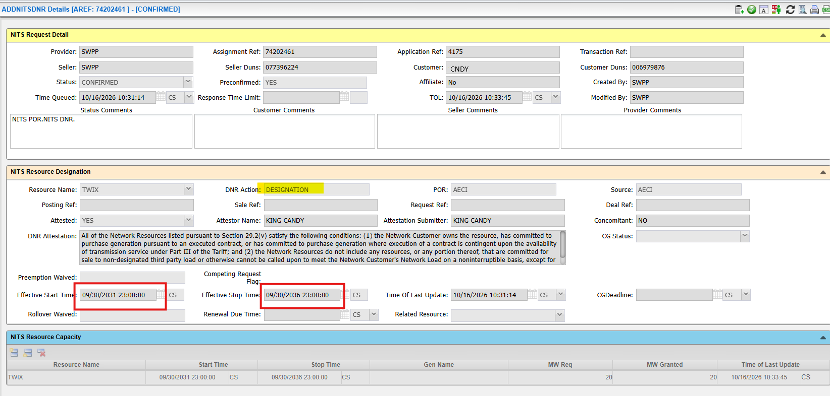
This should allow submission of the ADDNITSDNR rollover request.

Terms and Acronyms
Acronym | Term
SPP | Southwest Power Pool
TSR | Transmission Service Request
OATI | Open Access Technology International
OASIS | Open Access Same-Time Information System
DNR | Designated Network Resource
NITS | Network Integrated Transmission Service

